# Module 2 Assignments

## Section 1: Calculate Missing Values (10 points)

Using Ohms law calculate the missing value V=IR

1.

V = 14

I = ?

R = 2

14/2 = 7A

2.

V = ?

I = 9

R = 5

9*5 = 45V

3.

V = 24

I = 8

R = ?

24/8=3Ohm

4.

V = ?

I = 15

R = 5

15*5=75V

5.

V = 120

I = ?

R = 4

120/4 = 30A

Using the formula for Power P = VI calculate the missing value

6.

P = 72

V = ?

I = 6

72/6 = 12W

7.

P = ?

V = 6

I = 4

6*4=24W

8.

P = 6

V = 3

I = ?

6/3=2A

9.

P = ?

V = 12

I = 2

12*2=24W

10.

P = 64

V = ?

I = 8  
64/8 = 8V

## Section 2: Calculate Watts and Ohms (20 points)

11. Calculate the power in watts of a circuit with:

a) Resistance of 10 ohms and a current of 5 amps  
V=IR

P=VI

V=10*5 = 50V

P = 5*50 = 250W

1. Calculate the power in Watts of a circuit with resistance of 5 ohms and a current of 6 amps

V=IR

P=VI

V=5*6 = 30

P=30*5 = 150W

Side Question, could you simplify these questions to P=I^2R?

12. Calculate the resistance in ohms of a circuit with:

1. Power of 448 Watts and a current of 8 amps  
   R= V/I  
   V= P/I   
   V= 448/8 = 56  
   R= 56/8 = 7Ohm
2. Power of 6250 Watts and a current of 25 amps  
   R = V/I  
   V=P/I  
   V=6250/25 = 250  
   R=250/25 = 10Ohm

Side Question, could you simplify these questions to R=(P/I)/I ?

## Section 3: Truth Tables (20 points)

13. Fill in truth tables for the following circuit:

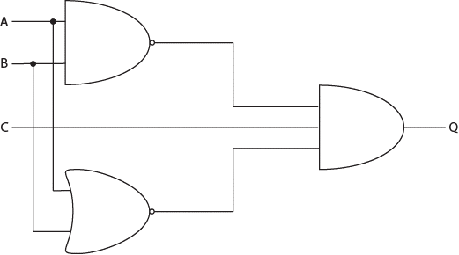

|  |  |  |  |
| --- | --- | --- | --- |
| A | B | C | Q |
| 0 | 0 | 0 | 0 |
| 1 | 0 | 0 | 0 |
| 0 | 1 | 0 | 0 |
| 0 | 0 | 1 | 1 |
| 1 | 1 | 0 | 0 |
| 1 | 0 | 1 | 0 |
| 1 | 1 | 1 | 0 |

14. Fill in truth tables for the following circuit:

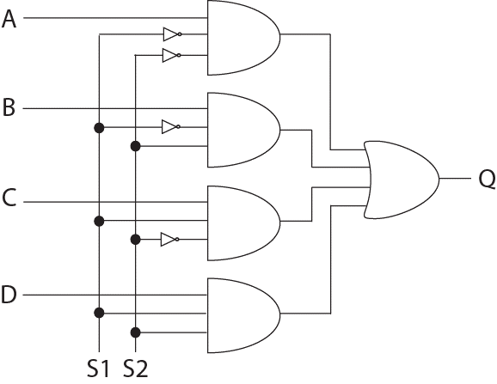

|  |  |  |  |  |  |  |
| --- | --- | --- | --- | --- | --- | --- |
| **S1** | **S2** | **A** | **B** | **C** | **D** | **Q** |
| 0 | 0 | 0 | 0 | 0 | 0 | 0 |
| 0 | 0 | 1 | 0 | 0 | 0 | 1 |
| 0 | 0 | 0 | 1 | 0 | 0 | 0 |
| 0 | 1 | 0 | 0 | 0 | 0 | 0 |
| 0 | 1 | 0 | 1 | 0 | 0 | 1 |
| 0 | 1 | 0 | 0 | 1 | 0 | 0 |
| 1 | 0 | 0 | 0 | 0 | 0 | 0 |
| 1 | 0 | 0 | 0 | 1 | 0 | 1 |
| 1 | 1 | 0 | 0 | 0 | 0 | 0 |
| 1 | 1 | 0 | 0 | 0 | 1 | 1 |

The input values for S1 and S2 determine which one of the inputs A, B, C or D controls the output value of Q. Fill out the following table to indicate which values of S1 and S2 select which line A, B, C, or D?

|  |  |  |
| --- | --- | --- |
| S1 | S2 | A, B, C or D |
| 0 | 0 | A |
| 1 | 0 | C |
| 0 | 1 | B |
| 1 | 1 | D |

## Section 4: Creating Circuits and Truth Tables (50 points)

Create circuit 1 and circuit 2 below and fill in the truth table. What logic gate does each circuit represent? Upload a photo of each circuit with the LED lit and unlit.

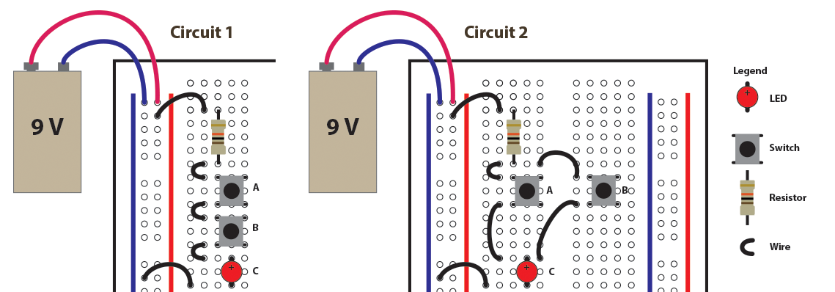

Note: The long pin of the LED is the positive pin.

|  |  |
| --- | --- |
| Circuit 1 | Circuit 2 |
| |  |  |  | | --- | --- | --- | | A | B | C | | 0 | 0 | 0 | | 1 | 0 | 0 | | 0 | 1 | 0 | | 1 | 1 | 1 | | |  |  |  | | --- | --- | --- | | A | B | C | | 0 | 0 | 0 | | 1 | 0 | 1 | | 0 | 1 | 1 | | 1 | 1 | 1 | |
| Logic Gate= ____AND___ | Logic Gate= __OR__ |